**EBUS633: Big Data Analytics for Business**

**Big Data Analytics for Food Waste Management**

Name: Aditi Aryan

Student Number:201594138

**CONTENTS:**

1. Motivation……………………………………………………………………………….3
2. Literature Review……………………………………………………………………. 3
3. Case Examples………………………………………………………………………… 6
4. Barriers…………………………………………………………………………………….14
5. Recommendations and Roadmap…………………………………………… 15
6. Conclusion……………………………………………………………………………….16
7. References……………………………………………………………………………….16

**MOTIVATION**

The scale of food waste problem is huge. Approximately 2/3rd of the food produced is wasted and only 1/3rd is for human consumption. Around 40 % of food produced in India is wasted due to lack of infrastructure to store the food and inefficient food supply chain.

Changes can be made to reduce damages caused by food waste. As part of food waste department in India, I suggest the use of big data tools and techniques like visualization and regression model to analyse different reasons contributing to food waste. The aim of my proposed project is reduction in food wastage.

This can be achieved in following ways:

* Optimize inventory levels
* Predict changes in demand
* Analyse seasonal change

Food waste reduction can be achieved after thorough analysis and different strategies and policy making based on this analysis by our department. Further in the report case examples of food waste management of different countries are discussed and how different policies and strategies by their government helped them to achieve their target. Efficient decision making plays an important role in accomplishing the goal set. Hence, examples of different countries food waste management in explained in the report.

**LITERATURE REVIEW:**

Effective food waste management can be done using reliable data analysis over different types of data for detailed in time waste generation information. Data Visualization and Regression can be used for effective planning:

* Data Visualization in Inventory Control: Efficient inventory management system can be implemented using the perks of data visualization. This can eventually be used to predict consumer behaviour and reduce food wastage. Large amount of complex data can be transformed into visual charts used for data analysis. (Chauhan, 2020) Data visualization simplifies complex data. It allows best possible preventable solution to a business problem. Inventory management can be very problematic if data had to be scanned from long spreadsheets. It makes data more comprehensive.

Example: Inventory control at university pantry using MVC software pattern and data visualization can be used for tracking system that collects real time data and then generated visual charts for data analysis. This can be used for better decision making and can lead to innovative solutions. This can be used to achieve better food waste management (tracking item expiration date so that item with early expiration date can be sold first), client satisfaction and retention (Ufot, Esterline and Bryant, 2021)

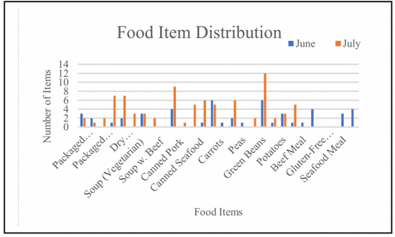



Figure 1 shows food item inventory of June and July 2019.Figure 2 shows food category inventory for same period. Figure 1 depicts green beans were most demanded. As it can be observed Pasta is most preferred food category by clients and snacks are third most preferred category. These results can be identified using these graphs than spreadsheets. These results can be used to predict consumer food choices using predictive techniques like regression and factory analysis.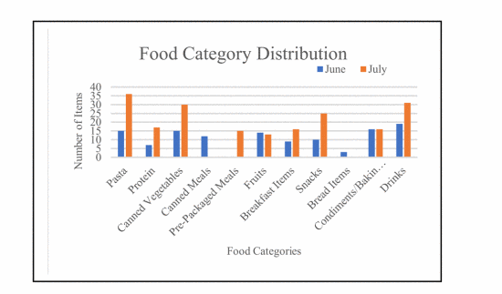



* Food production planning in context uncertainty in food wastage: Historical data of food company can be used to perform analysis to return uncertainty of food wastage. The different regression model can be helpful for identifying uncertainty of production planning and performance evaluation of individual components used to detect deficiencies and aid maintenance. This information can be incorporated with quality assurance to improve production standards. Different variable can be categorised into low waste and high waste which can be easily understood by stake holders of the food industry using the model. This will lead to smart manufacturing and can reduce waste and economic costs (transportation costs, packaging cost) as overproduction of perishable food items can lead to food wastage.

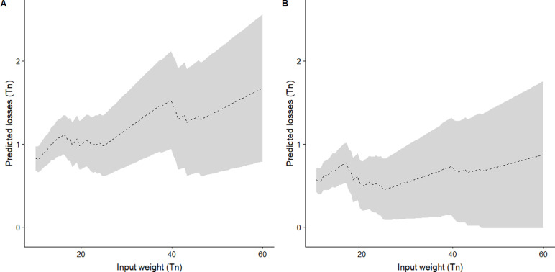



Example: Model can be used to predict food loss of two different recipes for different input variables. These input variables can be manipulated for food production planning. Dashed line represents expected loss and shaded area represents confidence level. (Garre, Ruiz and Hontoria, 2020)

**CASE EXAMPLES:**

Different real world case examples are discussed emphasizing on the use of visualization and regression technique used to handle food waste management.

* NORWAY FOOD WASTE (2013): Four years of data on food waste in Norway is discussed. This data was obtained from producers, retailers, wholesalers, and consumers. Systematic uniform methods were used to collect the data to ensure best comparability over time (Svanes, Oestergaard and Hanssen, 2018). The ForMat project is unique as no similar project in other countries which analyse trends in the development of food waste.

Data analysed from different stages were:

1. Production Stage: The company used scanning of usable food discarded in various stages of production. (Hanssen, Syversen and Stø, 2016)
2. Wholesaler Stage: 2 reasons of wastage were identified damage packing and short expiration date
3. Retailer Stage: Data from different shops were taken.
4. Consumer Stage: Data was analysed through surveys and questionnaire

(Hanssen, Syversen and Stø, 2016)

Results were analysis

Production Stage:



Wholesale Stage:



Retailer Stage:



Consumer Stage:



Performance Impact:

Consumer behaviour and attitude change over time helped reduce waste in Norway. The amount of food waste was analysed as a percentage of revenue across different categories. ForMat project took various initiatives to develop network projects across value chains in product groups to analyse the reasons of food wastage and measures to prevent. Lessons learned were to improve forecasting through closer cooperation between client and supplier and system of threefold division of product life between producer, wholesaler and retailer is too rigid and should reassessed.



There was a significant drop in the percentage of food wastage due to various reasons. Analysing the data and then taking preventive measures helped Norway to reduce food wastage.



* EU FOOD WASTE REDUCTION: Eurobarometer survey was conducted to collect the data from different EU countries. Various analysis and conclusion were done based on data collected. Based on results various policy makers made strategies aiming to reduce wastage at EU level also.

Helpful actions for EU-27 citizens identified as using freezers to conserve food for longer, better estimation of portion sizes to avoid food wastage and reusing leftover instead of throwing away. (Secondi, Principato and Laureti, 2015)

Multilevel framework to analyse the individual level and national level influence on food wastage was calculated using regression model.

The process in the question can be calculated by random effect and country level variance  This helped to estimate Intra class correlation representing the percentage of total unexpected variance among Europeans’ behaviour towards food wastage due to their country.

Various attitude and behaviour factors were also considered in the model.



Countries such as Czech Republic, Lithuania, Estonia, and Poland are less likely to waste food and countries like Denmark, Ireland and Sweden are more likely to waste food.

Regression model was also applied to understand the household food wastage. A positive association was observed with age. Older you are more likely to waste food.

Performance Impact:

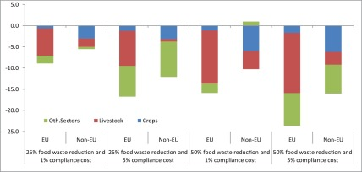



From this graph it can be observed that the greenhouse emission is expected reduce greater than Non-EU countries due to food wastage reduction as a performance impact from EU policies.

**BARRIERS:** There are different barriers that can impede successful adoption of visualization and regression. For doing analytics it important we have right data.

Social and legal barriers:

* Privacy: Data collected from survey or questionnaire may contain some personal questions. People would not want to share personal data. This personal data should be prevented from data leaks.
* Legal issues: Laws regarding collection, management and use of personal data can be very strict. As data on waste per household is treated as personal data. It should be properly secured.
* Lack of understanding: Lack of clear understanding of definition of food waste and related terms. (Pour and Makkawi, 2021)

Technical Barriers:

* Strong Data Management Platforms: Time and resource should be invested in strong data management platform before data collection starts. These data management platforms should be scalable to accommodate increasing volume and variety of data on waste.
* Team of domain experts needed: Data scientist and domain experts are needed to extract valuable information from large data set. Lack of this can lead to failure in valuable and insightful analysis (Dubey et al., 2017)
* Need for cybersecurity measures: As with large volume of data risks also increases. With expansion of data collection and implementation of new sensors. Sensors in waste bin pose a threat. Maintenance of software and sensors are not considered top priority.
* Human Errors: With more access to datasets increase in human errors increased.

Limitations: Data collected in waste industry is limited and has poor accuracy. This makes data unreliable as

* Undefined words or phrases
* Inconsistent or omitted units
* Dates, methodologies, or sources of data not indicated
* Estimates made without basis
* Incomplete or inconsistent data
* Information collected at non-representative moments (Celaj et al., 2017)

**RECOMMENDATIONS AND ROADMAP:** Different steps in the roadmap of how visualization and regression can be implemented in the project.

Step 1: Identify different factors contributing to food waste management. Factors like poor inventory management/retail, season change in demand etc. This phase requires a lot of research on different sources. This will take 1-2 months of project time.

Step 2: Work and build the conceptual model best suited for the project. This phase requires thorough understanding various input factors. What tools and techniques can be used on these factors to get meaningful insights and what will be the flow of the entire system. This will take 2-3 months of project time.

Step 3: Work on setting up the infrastructure for analytics like visualization and regression. This requires installation of softwares, and other setup devices required to carry out analytics. It is important to understand what software requirements the project are we carry working as there are plenty of softwares and devices available in the market. These should be selected based on performance and output it will provide and cost or the budget of the company. This will take 1 month of project time

Step 4: Train staffs and employee to analyse the data. Human resources are one of the most important resources for any organization. Sufficient time and money should be invested to get right skilled employee. This phase should take 4-5 months to get right skilled employees or train exiting employees in right skills.



Step 5. Implement the conceptual model in incremental phase. Test and analyse the first incremental phase and compare the results with initial results i.e results without this model. If the results are positive i.e it can reduce waste and increase profitability, then implement the model completely else analyse the weak points of the model and work on how it can be improvised.

Recommendations: the following can be implemented after getting insights to achieve the objective which to reduce food wastage.

* Sale promotion: Selling the products with early expiration date at discounted price to avoid wastage i.e target marketing (Patra et al., 2020)
* Smart Scanners: to keep a track of food items and its expiry date
* Awareness programs: to educate consumers about food wastage and its impact on environment. It can also include meal planning and shopping audit to avoid over cooking and excessive buying which results in food wastage, smart freeze and encourage to donate excessive food items

**CONCLUSION:**

The report highlights food waste problem as a global concern and how visualization and regression can be used to understand and analyse different factors. The report present 2 case examples of food waste management of Norway and EU countries and tools and techniques were used to analyse different root causes of food waste and based on these insights different policy and strategies were suggested which had significant impact of reducing food wastage in different food categories, different EU countries, different households etc. Similar approach is suggested and encouraged for food waste management in India. Report also covers possible challenges and barriers in implementing analytics in food waste department in India.

Limitations of the report are:

* The report is based on secondary analysis i.e., analysis done is from data collected and visualized by some other source.
* One of the performance impacts in the case example of EU is that by year 2030 it is expected to reduce greenhouse gas emission. We do not have data presently to verify that result now.

**REFERENCES:**

1.Barreto, L. and Amaral, A. (2018). Smart Farming: Cyber Security Challenges. [online] IEEE Xplore. Available at: <https://ieeexplore.ieee.org/abstract/document/8710531> [Accessed 23 Mar. 2022].

2.Celaj, D., Desmond, J., Shah, A., Shirai, S., Carrera, F. and Lauer, H. (2017). Preparing for the Use of Big Data in Denmark’s Waste Management Sector An Interactive Qualifying Project Report Submitted to the Faculty of the Sponsored by the Danish Waste Association. [online] Available at: <https://web.wpi.edu/Pubs/E-project/Available/E-project-101217-041523/unrestricted/Big-Data_Final_Report.pdf> [Accessed 23 Mar. 2022].

3.Chauhan, Y. (2020). Food Waste Management with Technological Platforms: Evidence from Indian Food Supply Chains. Sustainability, 12(19), p.8162.

4.Dubey, R., Gunasekaran, A., Childe, S.J., Papadopoulos, T., Luo, Z., Wamba, S.F. and Roubaud, D. (2017). Can big data and predictive analytics improve social and environmental sustainability? Technological Forecasting and Social Change.

5.Eriksson, M., Giovannini, S. and Ghosh, R.K. (2020). Is there a need for greater integration and shift in policy to tackle food waste? Insights from a review of European Union legislations. SN Applied Sciences, 2(8).

6.Garre, A., Ruiz, M.C. and Hontoria, E. (2020). Application of Machine Learning to support production planning of a food industry in the context of waste generation under uncertainty. Operations Research Perspectives, 7, p.100147.

7.Hanssen, O. and Møller, H. (n.d.). [online] Available at: <http://assets.fsnforumhlpe.fao.org.s3.amazonaws.com/public/discussions/contributions/Food_Waste_in_Norway_2013_-_Status_and_trends_2009-13_1.pdf> [Accessed 23 Mar. 2022].

8.Hanssen, O.J., Syversen, F. and Stø, E. (2016). Edible food waste from Norwegian households—Detailed food waste composition analysis among households in two different regions in Norway. Resources, Conservation and Recycling, 109, pp.146–154.

9.Patra, D., Leisnham, P.T., Tanui, C.K. and Pradhan, A.K. (2020). Evaluation of global research trends in the area of food waste due to date labeling using a scientometrics approach. Food Control, 115, p.107307.

10.Philippidis, G., Sartori, M., Ferrari, E. and M’Barek, R. (2019). Waste not, want not: A bio-economic impact assessment of household food waste reductions in the EU. Resources, Conservation and Recycling, 146, pp.514–522.

11.Pour, F.H. and Makkawi, Y.T. (2021). A review of post-consumption food waste management and its potentials for biofuel production. Energy Reports.

12.Secondi, L., Principato, L. and Laureti, T. (2015). Household food waste behaviour in EU-27 countries: A multilevel analysis. Food Policy, 56, pp.25–40.

13.Svanes, E., Oestergaard, S. and Hanssen, O. (2018). Effects of Packaging and Food Waste Prevention by Consumers on the Environmental Impact of Production and Consumption of Bread in Norway. Sustainability, 11(1), p.43.

14.Ufot, J., Esterline, A. and Bryant, K.S. (2021). Inventory Control at a University Food Pantry Using an MVC Software Pattern and Data Visualization. [online] IEEE Xplore. Available at: <https://ieeexplore.ieee.org/abstract/document/9401894> [Accessed 22 Mar. 2022].

15.Usman Sarfraz, K. (2019). Reducing food waste at retail stores using business intelligence (BI) tools and methods.